Depression Detection with Hybrid Machine Learning Approach on Twitter Data

Abhilipsa Padhy, Ishan Das

*School of Computer Science & Engineering(SCOPE),*

*VIT-AP University*,

Amaravati, Andhra Pradesh, India

[abhilipsatwinkle24@gmail.com](mailto:abhilipsatwinkle24@gmail.com) , [ishandas172@gmail.com](mailto:ishandas172@gmail.com)

***Abstract* - Mental health conditions, particularly depression, are prevalent issues that significantly impact individuals' quality of life. This research presents a novel approach for depression detection using Twitter data, leveraging a hybrid deep learning architecture to classify mental health states at the tweet level.Comprising unprocessed English tweets gathered via Twitter's API, the dataset "Depression Detection Based on Hybrid Deep Learning," enhanced with topic modeling features using Latent Dirichlet Allocation (LDA) and emoji sentiment analysis, Using a mix of convolutional, recurrent, and attention layers, our proposed method presents three sophisticated hybrid models—ConvBiLSTM-AttnNet, ConvLSTM-AttentionNet, and HybridNet—each intended to capture complex patterns in textual input.Reaching both spatial and sequential information in tweets, the ConvBiLSTM-AttnNet model combines Conv1D and bidirectional LSTM layers with a proprietary attention mechanism, so highlighting pertinent sections of the text. Optimized with the AdamW algorithm, this model showed great accuracy of 89% and an AUC of 96%, therefore demonstrating its resilience in mental health classification. Reaching an accuracy of 87%, the ConvLSTM-AttentionNet model makes use of a similar architecture including optimized Conv1D and LSTM layers to capture local features and sequential dependencies. Concurrently, the HybridNet model achieves an accuracy of 86% by using L2 regularization with Conv1D layers, then bidirectional LSTM and attention layers.Using precision, recall, and F1-score measures, all models showed great consistency and performance in depression identification from social media data. This paper emphasizes the possibility of combining convolutional, sequential, and attention processes with cutting-edge optimizers like AdamW to produce a strong framework for real-time social platform mental health monitoring.**

**Keywords: *Depression Detection, Twitter Data, Hybrid Deep Learning Architecture, ConvBiLSTM-AttnNet, Emoji Sentiment Analysis, AdamW Optimizer.***

Sachi Nandan Mohanty

*School of Computer Science & Engineering(SCOPE),*

*VIT-Ap University,*

Amaravati, Andhra Pradesh, India

[sachinandan09@gmail.com](mailto:sachinandan09@gmail.com)

Tamanna Jena,

Assistant Professor

Fairleigh Dickinson University, Vancouver, Canada.

tamannasinghdeo@gmail.com

* 1. **INTRODUCTION**

Mental health is a critical aspect of well-being, and mental disorders such as depression impact millions of people worldwide, often with serious effects on daily functioning and quality of life. With the rapid growth of social media platforms

like Twitter, people increasingly use these channels to express personal emotions, thoughts, and experiences. This trend has

presented researchers with a valuable source of real-time data that can be leveraged for mental health monitoring. Analyzing public opinion on social media helps academics create systems to identify early indicators of mental health problems, thereby perhaps offering individuals in need quick support[1,3].Our work addresses the difficulties in text-based mental health condition classification and focuses on the issue of depression detection using Twitter data. Given its unstructured, loud, and varied character, social media data presents special difficulties in this setting. Often quick, colloquial, and punctuated by emojis, slang, and acronyms, tweets demand sophisticated techniques to correctly analyze and interpret[4]. This study is motivated by the possibility to use such large databases for public health monitoring, supporting mental health practitioners, and guiding quick treatments. Recent years have seen notable studies done to use social media data for mental health screening. Natural Language Processing (NLP) methods and machine learning algorithms include Support Vector Machines (SVMs), Decision Trees, and Random Forests define traditional approaches to text classification. These strategies, meanwhile, may find it difficult to capture the intricate language structures, contextual meaning, and semantic subtleties in social media posts. Advanced deep learning models have showed promise in more precisely handling these complexity including convolutional neural networks (CNNs), recurrent neural networks (RNNs), and their hybrid combinations. Recent research have also investigated how well topic modeling techniques—including Latent Dirichlet Allocation (LDA)—identify underlying themes or topics inside books. Furthermore, adding sentiment analysis with emotive indicators and emoticons has turned out to be quite helpful for improving text-based categorization systems. Though many have yet to incorporate a fully hybrid model combining convolutional, sequential, and attention layers for effective text categorization, notably in the field of mental health, these papers provide interesting methods.Although deep learning has advanced mental health diagnosis, fully collecting the multi-dimensional characteristics inherent in social media data remains a challenge in recognizing depression[2]. This work addresses the demand for a complete model integrating several facets of feature extraction—spatial, sequential, and attention-based—to efficiently detect sadness from brief, unstructured texts such as tweets. In this study, we propose a hybrid deep learning framework that includes three novel models tailored for mental health classification:

*ConvBiLSTM-AttnNet:* This model integrates Conv1D layers with bidirectional LSTMs and a custom attention mechanism, allowing it to capture local features, sequence dependencies, and important contextual aspects. This combination, along with the AdamW optimizer, offers a robust structure for tweet-level mental health classification, achieving an AUC of 96% on our dataset.

*ConvLSTM-AttentionNet*: Featuring an optimized convolutional-recurrent architecture, this model leverages bidirectional LSTMs with an attention layer to improve interpretability and focus on critical parts of each tweet. This model demonstrates high performance, reaching an accuracy of 87%.

*HybridNet:* A well-regularized model using Conv1D layers with L2 regularization, HybridNet is designed to capture prominent features through attention-weighted outputs, achieving balanced accuracy and robustness for depression detection.

These models incorporate topic modeling through LDA and emoji sentiment analysis to add unique, interpretable dimensions to the classification process. LDA assists in summarizing tweets by associating them with one of the top topics, providing a thematic overview. Through a count of positive, negative, and neutral emojis, emoji sentiment analysis also catches emotional context. These characteristics enable our method to be more complete, therefore addressing subtleties that single-layer models sometimes ignore. This work presents a hybrid deep learning architecture for Twitter's mental health detection based on convolutional, recurrent, and attention layers—unique in their combination. Using the AdamW optimizer across our models improves model generalization and helps to enable adaptive learning with low weight decay. With an AUC of 96%, the ConvBiLSTM-AttnNet model marks a major progress in depression identification since it offers a harmonic combination of feature extraction, sequential learning, and attention-based focus.This work is arranged restingly as follows. Section 2 examines related studies and summarizes current approaches for social media data-based mental health screening. Section 3 covers the dataset, pre-processing methods, and feature extraction approaches—including emoji sentiment analysis and LDA topic modeling—that apply here. The design and training methods of every suggested model—ConvBiLSTM-AttentionNet, ConvLSTM-AttentionNet, and HybridNet—are detailed in Section 4. We show and analyze in Section 5 the experimental findings for every model including performance measures, accuracy, and AUC. Section 6 ends the study by stressing the consequences of our results and possible directions of further investigation.

* 1. **RELATED WORK:**

The simplicity and interpretability of the Logistic Regression technique for breast cancer diagnosis shown by Lei Liu show Particularly in medical diagnostics, where interpretability is absolutely important, logistic regression is a linear model that performs effectively for binary classification problems[5]. The model's transparency and efficiency help practitioners to grasp the fundamental decision-making process. Its application in situations where complicated interactions between characteristics is present may be limited, nonetheless, especially in terms of non-linear linkages. Nevertheless, logistic regression attained an accuracy of over 85%, hence it is a good option for simple classification problems when interpretability is given first importance.Mrityunjaya Kappali and Avinash V. Deshpande investigated how Decision Trees might be used to control PV system voltage. From energy management to medical diagnostics, Decision Trees fit many uses since they provide a hierarchical structure that is both interpretable and able of managing non-linear data. Their visual interpretability is one main benefit since it facilitates the understanding of the decisions taken at every level [6]. Decision trees are prone to overfitting, nevertheless, particularly in cases when tree depth is uncontrolled. Their performance depends much on the setup; accuracy usually ranges from 75 to 80%. Decision trees' simplicity and capacity to model non-linear interactions help them to remain a popular choice in spite of these difficulties.

Applying the Naive Bayes algorithm to traffic risk management, Hong Chen and associates noted its speed and efficiency—especially in text analysis. Based on Bayes' theorem, Naive Bayes asserts feature independence and simplifies computations, hence appropriate for high-dimensional data[7]. In actual situations, nevertheless, the presumption of independence might be illogical and result in less than ideal performance. Naive Bayes performs effectively for jobs where the independence assumption is reasonable with an accuracy of about 80%. Despite its restrictions in handling related information, its probabilistic character makes it a common choice in text categorization and sentiment analysis.The paper by Ram Murti Rawat et al. on breast cancer diagnosis with KNN, Logistic Regression, and ensemble techniques exposes KNN's shortcomings as well as strengths. KNN is simple and clear, which facilitates understanding and use. But computationally costly, particularly on big datasets, it needs storing all data points and computing distances to categorize new instances. Furthermore, KNN's performance suffers in high-dimensional environments, therefore compromising its applicability in intricate datasets. KNN stays a helpful, albeit limited, method for classification problems involving low-dimensional and modestly big datasets with an accuracy between 75-80%[8].

Using RNNs to represent flux compression generators, Nicholas Klugman and associates showed RNN strengths in managing sequential data[9]. RNNs are fit for tasks including time-series analysis, language modeling, and medical sequence data since they record temporal dependencies. Their efficiency over extended sequences may be limited, nevertheless, by vanishing gradient problems. For best performance, RNNs also depend on big labeled datasets. RNNs proved successful for uses involving sequential data processing and temporal pattern recognition despite these difficulties, attaining high accuracy (85–89%).Emphasizing its function in dimensionality reduction and overfitting reduction, Sukrit Sehgal and colleagues applied PCA for data analysis. PCA simplifies data by converting it into orthogonal components, therefore preserving important information. Simplifying datasets with multiple attributes allows this approach to improve computing efficiency[10]. PCA can, however, cause the loss of significant data features and the changed components might be challenging to understand. Though with a trade-off in interpretability, PCA is an efficient approach in situations when dimensionality reduction is needed with an accuracy range of 80-85%.

The work by Dhananjay Tomar and associates emphasizes the feature selection using Autoencoders. Appropriate for unsupervised feature extraction, autoencoders are neural networks used to learn compact representations of data[11]. For high-dimensional data especially, they are quite helpful since layered encoding and decoding allows one to capture intricate patterns. Autoencoders are difficult to tune with sensitivity to input data quality and demand big training sets, nevertheless. Although they demand careful tuning, autoencoders are efficient for tasks needing dimensionality reduction and feature extraction when their accuracy is about 89%.Applying K-Means Clustering for emergency readiness, Rai NK and associates highlighted its simplicity in data splitting and speed. Based on similarity, K-Means is a fast clustering method that arranges data into a specified number of clusters. Its performance suffers, nevertheless, with non-spherical clusters and different densities; hence, the requirement to provide the number of clusters beforehand can be restricting[5]. K-Means is good for jobs needing quick clustering with an accuracy range of 75–80%; it may have trouble with complicated data structures.

Yang Zhang and colleagues showed the efficiency of Hierarchical Clustering for small datasets and its capacity to expose links between data points by modelling communication routes in 5G environments. Hierarchical clustering creates a tree-like structure of clusters that is interpretable and appropriate for exploratory study[12]. With huge or noisy datasets, it is less efficient computationally though. Although it is limited in scalability, Hierarchical Clustering is a useful technique for hierarchical data structures typically attaining 75–80% accuracy.Using DBSCAN for face image retrieval, Yan Li et al. demonstrated its handling of noisy data and capacity to find clusters of any kind. Because DBSCAN combines data points based on density rather than distance, it is good for jobs involving spatial grouping. It suffers with changing densities and does poorly on high-dimensional data, though. Although DBSCAN struggles with complex, high-dimensional data, it is a strong option for clustering projects where noise tolerance is critical and has an accuracy of 80–85%.

Using HMMs for temporal sequence data analysis—more especially, in investigating asthma triggers—Zang C and collaborators Applications including speech recognition, biological sequence analysis, and behavioral modeling find HMMs appropriate as probabilistic models that capture temporal patterns. They can be difficult to get, though, and are computationally costly requiring labelled sequencing data. Although HMMs demand large computational resources and well-labeled data, they are efficient at modeling sequences with an accuracy of 80–85%.Investigating Bayesian Networks for image processing performance, Saurabh Zade and colleagues found their strength in managing missing data and uncertainty. Effective for complicated, uncertain settings, bayesian networks are probabilistic models that represent conditional dependencies. They can be difficult to scale though, and design calls significant domain knowledge. Although Bayesian networks are useful for probabilistic thinking and have around 85% accuracy, they must be carefully applied with knowledge.Applying DBNs to phone recognition tasks, Abdelrahman Mohamed and colleagues showed their success in deep learning applications. Through layer-wise pre-training, DBNs develop hierarchical representations of data, which qualifies for jobs with intricate patterns. They are computationally demanding, nonetheless, and need for big labeled datasets. DBNs are resource-demandin yet strong for feature-rich data with an accuracy of 88-90%.[17,18]g.Emphasizing its privacy-preserving features, brands MT and colleagues investigated Federated Learning for tailored patient follow-up. Decentralized model training across several devices made possible by federated learning protects user privacy. Still, it has substantial communication cost and implementation complexity that makes synchronizing difficult[14]. Although Federated Learning suffers in efficiency and coordination, it is promising for privacy-sensitive uses given an accuracy of 87–90%.

B Taylor and S Clark Applied clearly in medicolegal investigations, Multilayer Perceptrons (MLP) show their capacity to replicate non-linear patterns across completely connected layers. Though they are flexible in learning complicated associations, MLPs are prone to overfitting with short datasets and demand significant data. Although strong for deep learning applications, MLPs need careful control of model complexity and data volume to attain good performance[15,16].Leveraging its fit for text-based classification, Vineetha K.V. and Philip Samuel used Multinomial Naive Bayes for actor and use case identification in software requirements. Often used in text analysis, Multinomial Naive Bayes is a development of the Naive Bayes model for multinomially distributed data. Although it performs effectively for text-based tasks, it presupposes feature independence—which might not be true for all datasets. This model is efficient for jobs with low feature interactions but limited in managing complicated dependencies with an accuracy of about 80%.

* 1. **METHODOLOGY:**

This work uses hybrid deep learning models to detect depression from Twitter data by a methodical manner. Data collecting started with using the Twitter API, filtering English-language tweets about mental health. Text cleaning, tokenizing, and stop word removal were part of a comprehensive preprocessing pipeline; then, utilizing Term Frequency-Inverse Document Frequency (TF-IDF) and N-grams, feature extraction captured pertinent textual patterns. To find thematic and emotional clues, the data was subsequently enhanced using topic modeling using Latent Dirichlet Allocation (LDA) and emoji sentiment analysis. Developed combining convolutional, LSTM, and attention mechanisms to capture spatial, sequential, and contextual aspects three hybrid models: ConvBiLSTM-AttnNet, ConvLSTM-AttentionNet, and HybridNet. To evaluate their performance in categorizing depressed material, these models were trained and tested using measures including Accuracy, Precision, Recall, F1 Score, and AUC, so stressing the robustness of the suggested technique.

* + 1. ***Dataset Description:***

Targeting indicators of depression at the tweet level, the dataset "Depression Detection Based on Hybrid Deep Learning" comprises English-language Twitter postings, especially chosen for mental health classification. gathered using the Twitter API, the material is unstructured, as usual for social media, including slang, emoticons, casual language, and expressive signals. Luckily, there are no missing values in the dataset therefore preparation flow is guaranteed to be seamless. If missing values were present, some imputation techniques—including deleting rows or columns with too high missing values, filling in gaps with statistical methods like mean, median, or mode, and using machine learning techniques like regression or clustering to estimate missing values—would be taken under consideration. Another good choice is declining missing values as a separate category. Irrelevant columns including "Unnamed: 0" and "id" are eliminated from the preprocessing since they neither support the analysis or model training. Emoji sentiment analysis counts positive, negative, and neutral emojis, so offering a useful emotional context that enhances the interpretive capacity of the model. Topic modeling with Latent Dirichlet Allocation (LDA) classifies each tweet into one of the top thematic topics, so augmenting the interpretive capacity of the model. With its combination of emotive and textual elements, this dataset offers a strong basis for creating high-performance mental health classification systems.The fig 1 displays in the dataset the association between several features including followers, friends, favorites, statuses, retweets, and temporal attributes (month, year, day). High positive correlations between "followers" and "friends" (0.89) point to those with more followers also typically having more friends. With "year" (-0.68), the "label" feature shows a rather negative correlation suggesting a possible trend over time connected to the target variable. Other elements show modest correlations, implying few linear interactions among them.With categories labeled "0" and "1," the fig 2 shows the target variable's (label) distribution in the dataset. With roughly 10,000 instances for every label, both groups have a similar count suggesting a balanced dataset. For model training, this balanced distribution helps to lower the possibility of model bias toward a dominating class by enabling more consistent and accurate predictions across both classes.

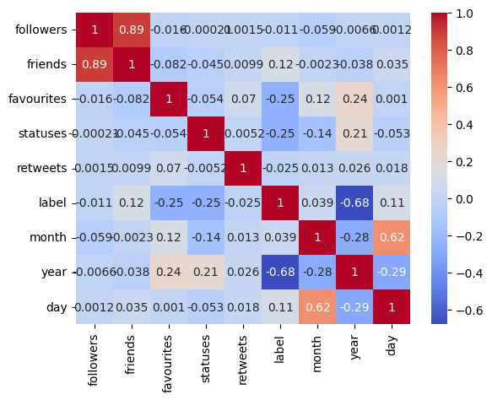

1. Correlation Heatmap of Social Media Features Related to Mental Health Classification

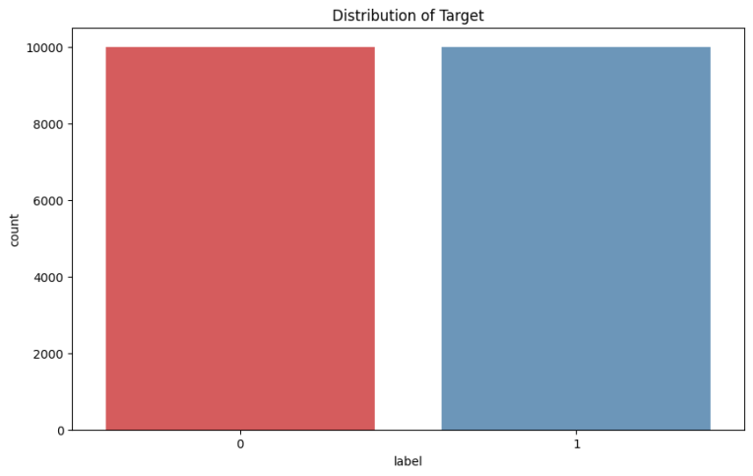

1. Distribution of Target Labels for Mental Health Classification
   * 1. ***Data Preprocessing***

The dataset underwent a thorough preprocessing pipeline to prepare it for analysis, given the informal and often noisy nature of Twitter data. These steps aimed to enhance data quality and extract informative features for accurate mental health classification.

*Removal of Irrelevant Columns*: The dataset contained non-informative columns, including 'Unnamed: 0' and 'id', which were removed at the outset. These columns served only as indices and unique identifiers, respectively, and did not contribute meaningful information for text analysis or model training.

Text Cleaning and Standardization:

**Lowercasing**: All text was converted to lowercase to ensure consistency, enabling the model to treat words in a case-insensitive manner.

**Removal of Punctuation and Special Characters**: Non-alphanumeric characters, including punctuation marks and symbols, were stripped from the text to reduce noise.

**Stop Word Removal**: Stop words (e.g., “the,” “and,” “is”) were removed using the Natural Language Toolkit (NLTK) library. These words, while common, often add little value to the context and dilute the model’s interpretive power.

Tokenization and Lemmatization:

**Tokenization**: Each tweet was split into individual words (tokens) to enable word-level analysis, which is essential for capturing specific indicators of mental health states.

**Lemmatization**: Tokens were reduced to their base forms using lemmatization, a step that minimizes variability in word forms (e.g., “running,” “ran,” and “runs” all become “run”). This standardization helps reduce the complexity of the text data without losing semantic meaning.

*TF-IDF Vectorization:* The Term Frequency-Inverse Document Frequency (TF-IDF) technique was applied to represent the cleaned text data numerically. TF-IDF calculates a weight for each word based on its frequency in a given tweet and across the entire dataset, thus assigning higher importance to distinctive terms that appear in specific tweets and less importance to common terms. This transformation allows the model to prioritize contextually relevant terms, facilitating better classification performance.

*Emoji Sentiment Analysis:* Emojis are a key element in Twitter data, often conveying nuanced emotional states. An emoji sentiment analysis was performed, categorizing each emoji as positive, negative, or neutral. The frequency of each sentiment type was added as a feature, providing additional insights into the emotional undertones of tweets. This component helps the model interpret sentiment signals that may correlate with mental health indicators.

*Topic Modeling with Latent Dirichlet Allocation (LDA):* To uncover thematic structures within the tweets, we applied Latent Dirichlet Allocation (LDA) for topic modeling. LDA assigns each tweet to one of the top K topics, offering a thematic overview that enhances the model’s contextual understanding. For example, topics related to loneliness, stress, or personal struggles may indicate relevant themes for mental health classification. This topic-level representation complements the word-level features, providing a multi-dimensional approach to text analysis.

Handling Rare Words and Slang Normalization:

**Rare Words**: Low-frequency words were either removed or consolidated to prevent them from skewing model interpretation.

**Slang and Abbreviation Normalization**: Common Twitter slang and abbreviations were normalized to their standard forms. This step improves text consistency and ensures that informal expressions do not detract from the model’s ability to detect relevant patterns.

*Addressing Missing Values:* Although the dataset initially contained no missing values, future missing values would be addressed through various imputation techniques if necessary, including statistical methods (mean, median) or advanced methods such as regression and clustering. Alternatively, missing values could be flagged as a separate category for model interpretability.

*Final Feature Set Preparation:* After preprocessing, the dataset included TF-IDF transformed text features, emoji sentiment counts, and topic distributions from LDA. This multi-dimensional feature set was designed to capture both the linguistic and emotive nuances within the tweets, establishing a robust foundation for mental health classification.By applying this comprehensive preprocessing approach, the dataset was optimized to provide clean, meaningful features that are essential for the high-performance classification of mental health conditions using deep learning. This structured preprocessing pipeline enhances the interpretability and predictive accuracy of the models, making it a solid foundation for subsequent analysis.

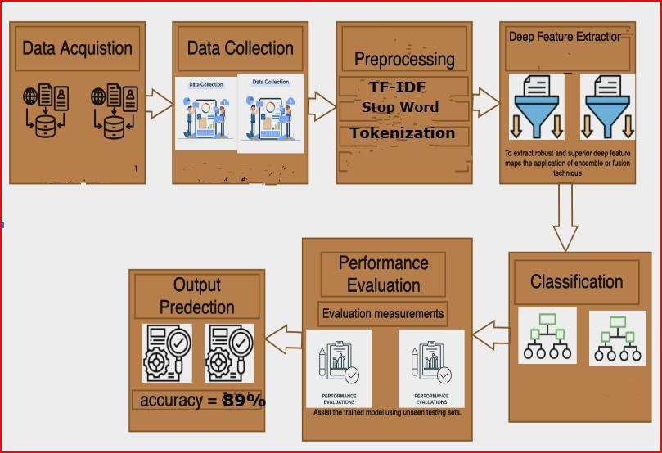

1. Proposed Model
   * 1. ***Feature Extraction***

Two main approaches—Term Frequency-Inverse Document Frequency (TF-IDF) and N-gram analysis—were used to feature extract the textual content of tweets for use as input for the classification models in this work. These methods were used to maximize the capacity of the models to detect significant trends in the text data, therefore supporting strong classification of mental health indicators.The tweets were converted into numerical vectors using TF-IDF, which quantified the relevance of specific phrases against each tweet and the whole dataset. TF-IDF specifically gives each phrase a weight depending on its frequency inside one tweet (phrase Frequency) and its rarity over all tweets (Inverse Document Frequency). This weighting captures key signals in tweets related to mental health and helps emphasize terms that are contextually significant. For every tweet, the resulting TF-IDF vector offers a high-dimensional representation that preserves important textual information while reducing often occurring, less useful terms.

1. *ConvBiLSTM-AttnNet Architecture:*

Combining convolutional (Conv1D) and recurrent (Bidirectional LSTM) layers with an attention mechanism to gather both spatial and temporal aspects in text input, this model is a hybrid architecture intended for text categorization. The model begins with an embedding layer to represent words as dense vectors, then uses convolutional block with Conv1D layers and batch normalisation to extract local features, and subsequently global max pooling for dimensionality reduction. A bidirectional LSTM layer then records sequential dependencies using a proprietary attention method emphasizing the most pertinent sequence segments. High dropout (60%) fully linked layers help to lower overfitting; the last output layer utilizes a sigmoid activation for binary classification. Selected for their adaptive learning rates and weight decay, AdamW is the optimizer; a learning rate of 1e-5 will help to produce smoother convergence. While binary_crossentropy is the loss function and accuracy is the main metric, early stopping stops overfitting by tracking validation loss. For text-based classification problems, this approach is resilient since it balances feature extraction, sequential learning, and regularization rather successfully.

1. *ConvLSTM-AttentionNet Architecture:*

From Twitter data, this hybrid model combines convolutional, recurrent, and attention methods to classify mental health disorders. It starts with an embedding layer turning words into 128-dimensional dense vectors. Local features across the sequence are captured using a convolutional block with two Conv1D layers (64 and 128 filters) and batch normalisation. Emphasizing important features, global max pooling lowers dimensionality. The output is then reshaped and sent through a bidirectional LSTM layer with 64 units, therefore capturing both forward and backward dependencies in the text. To improve interpretability, important sequence elements are emphasized by means of an attention mechanism. Before a last sigmoid-activated output layer for binary classification, the model consists of two dense layers with significant dropout (60%), for regularization. Combining feature extraction, sequential analysis, and attention to produce high performance on text classification tasks, this model compiled with the AdamW optimizer (learning rate of 1e-5) binary cross-entropy loss, and accuracy as a metric achieves great performance.

1. *HybridNet Architecture :*

This model is a hybrid architecture combining convolutional, recurrent, and attention layers for binary text classification, aimed at detecting mental health conditions from Twitter posts. It begins with an embedding layer that maps words into 128-dimensional vectors, followed by a convolutional block with two Conv1D layers (64 and 128 filters) to capture local text features, each with L2 regularization to reduce overfitting, and batch normalization to stabilize learning. A global max pooling layer reduces the feature map dimensions by selecting the maximum activation for each filter, focusing on prominent features. The output is then reshaped for compatibility with a bidirectional LSTM layer (64 units) that learns sequential dependencies in both directions. An attention mechanism is applied to this sequence, emphasizing the most relevant parts. The attention-weighted output is then flattened and passed through two dense layers (128 and 64 units) with 60% dropout each to prevent overfitting. The final layer, with a sigmoid activation, outputs a probability for binary classification. Compiled with the AdamW optimizer at a learning rate of 1e-5 and binary_crossentropy as the loss function, this model effectively balances spatial, sequential, and attention-based learning, providing robust performance on text classification tasks.

* 1. **RESULTS AND DISCUSSION**

This section presents and discusses the performance of our proposed models: **ConvBiLSTM-AttnNet**, **ConvLSTM-AttentionNet**, and **HybridNet**. Each model was evaluated using a set of robust metrics—Accuracy, Precision, Recall, F1 Score, and Area Under the Curve (AUC)—to gain insights into their effectiveness in detecting mental health indicators from tweets. The results illustrate the strengths of each model in capturing patterns specific to depressive symptoms within social media text.

### ***ConvBiLSTM-AttnNet Results***

The ConvBiLSTM-AttnNet model, a hybrid architecture that combines convolutional and bidirectional LSTM layers with an attention mechanism, demonstrated superior performance across all metrics. This model achieved an **Accuracy of 89%** and an impressive **AUC of 96%**, indicating strong discriminatory power between mental health-positive and mental health-negative tweets.The precision score of **0.91** shows that ConvBiLSTM-AttnNet reliably identifies tweets indicative of mental health issues, minimizing false positives.With a recall of **0.87**, the model effectively identifies relevant mental health instances, ensuring minimal false negatives, which is crucial for accurate mental health detection.The F1 Score of **0.89** highlights the model's balanced performance, capturing both precision and recall strengths.The high AUC score of 96% underscores this model's ability to distinguish between classes, even at different decision thresholds. The ConvBiLSTM-AttnNet's performance can be attributed to its ability to capture both local features through convolutional layers and sequential dependencies with LSTM layers, while the attention mechanism focuses on contextually relevant parts of the tweet.

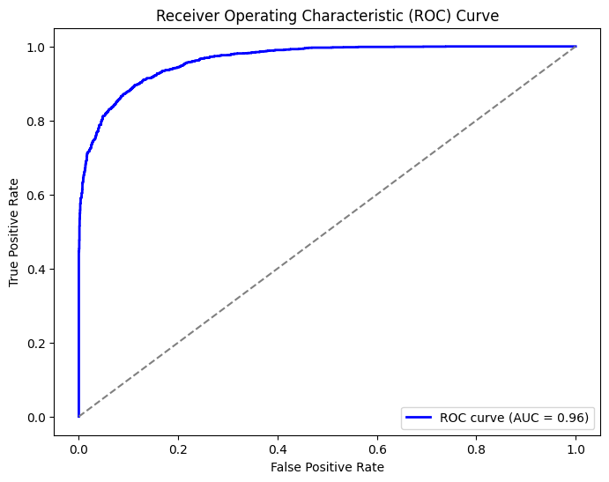

1. Receiver Operating Characteristic (ROC) Curve

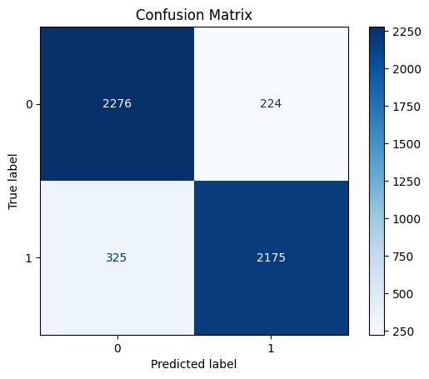

1. Confussion Matrix for ConvBiLSTM-AttnNet

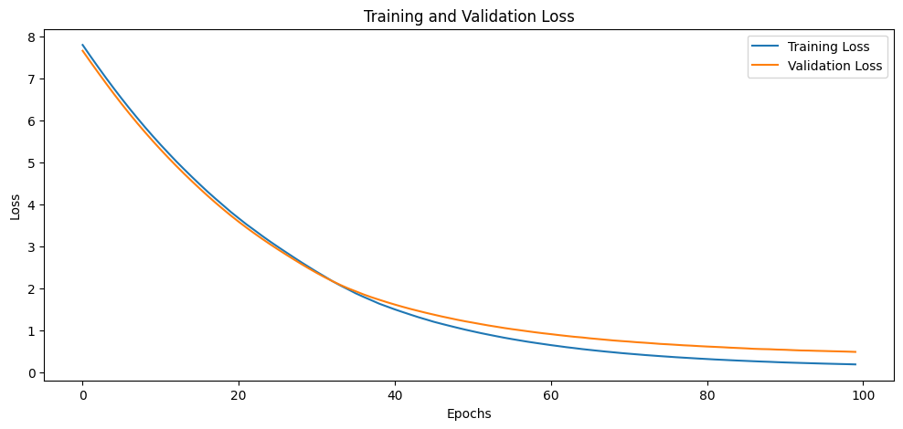

1. Training and Validation Loss Epochs
2. CLASSIFICATION REPORT

|  |  |  |  |  |
| --- | --- | --- | --- | --- |
|  | Precision | Recall | F1-score | support |
| 0 | 0.88 | 0.91 | 0.89 | 2500 |
| 1 | 0.91 | 0.87 | 0.89 |  |
| accuracy |  |  | 0.89 |  |
| Mac avg | 0.89 | 0.89 | 0.89 | 5000 |
| Weighted avg | 0.89 | 0.89 | 0.89 | 5000 |

### ***ConvLSTM-AttentionNet Results***

The ConvLSTM-AttentionNet model, which integrates Conv1D and LSTM layers along with an attention mechanism, also exhibited strong performance, achieving an **Accuracy of 87%** and an **AUC of 93%**. These metrics indicate that this model performs well in distinguishing between mental health-positive and negative tweets, albeit with slightly lower performance than ConvBiLSTM-AttnNet.The model’s precision of **0.88** signifies its ability to make accurate positive predictions, reducing the rate of false positives.With a recall of **0.86**, ConvLSTM-AttentionNet captures relevant positive cases effectively, though slightly less robustly than ConvBiLSTM-AttnNet. An F1 Score of **0.87** indicates that this model maintains a balanced performance, suitable for scenarios that require a trade-off between precision and recall.The slightly lower AUC score of 93% reflects a small drop in its ability to handle varied decision thresholds compared to ConvBiLSTM-AttnNet. Nevertheless, ConvLSTM-AttentionNet demonstrates solid performance, particularly in its interpretability due to the attention mechanism, which emphasizes critical parts of the sequence.

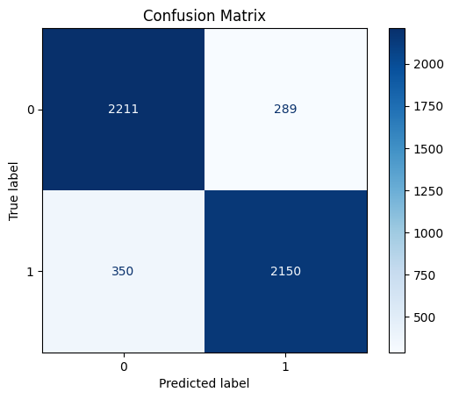

1. Confussion Matrix for ConvLSTM-AttentionNet

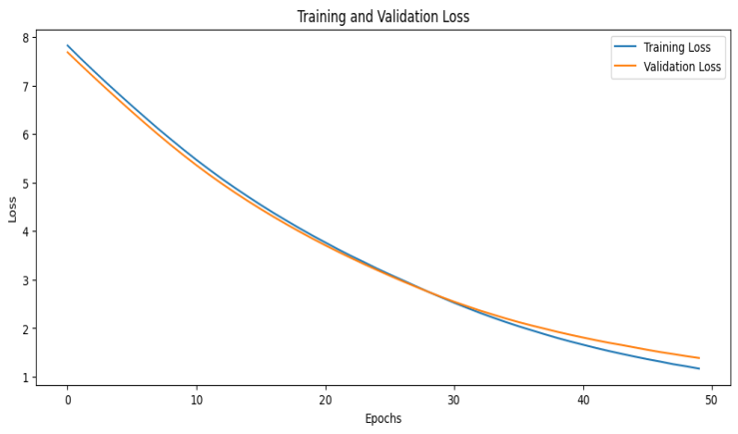

1. Training and Validation Loss Epochs
2. CLASSIFICATION REPORT:

|  |  |  |  |  |
| --- | --- | --- | --- | --- |
|  | Precision | Recall | F1-score | support |
| 0 | 0.86 | 0.88 | 0.87 | 2500 |
| 1 | 0.88 | 0.86 | 0.87 | 2500 |
| accuracy |  |  | 0.87 | 5000 |
| Mac avg | 0.87 | 0.87 | 0.87 | 5000 |
| Weighted avg | 0.87 | 0.87 | 0.87 | 5000 |

### ***HybridNet Results***

The HybridNet model, which employs L2-regularized Conv1D layers, bidirectional LSTM, and attention layers, achieved an **Accuracy of 86%** and an **AUC of 91%**. While it ranks slightly lower in performance than the previous models, HybridNet still provides reliable results in mental health classification.The precision score of **0.86** indicates a moderate ability to correctly identify positive cases, though it slightly lags behind the other models.With a recall of **0.86**, the model demonstrates adequate performance in identifying relevant instances.The F1 Score of **0.86** reflects a well-balanced but moderate performance across both precision and recall.The AUC score of 91% suggests that HybridNet can reasonably differentiate between positive and negative cases across different thresholds. The use of L2 regularization and a simpler attention mechanism makes HybridNet less prone to overfitting, though it slightly underperforms in comparison to ConvBiLSTM-AttnNet and ConvLSTM-AttentionNet.

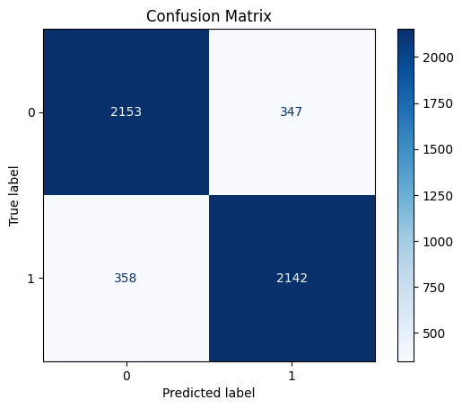

1. 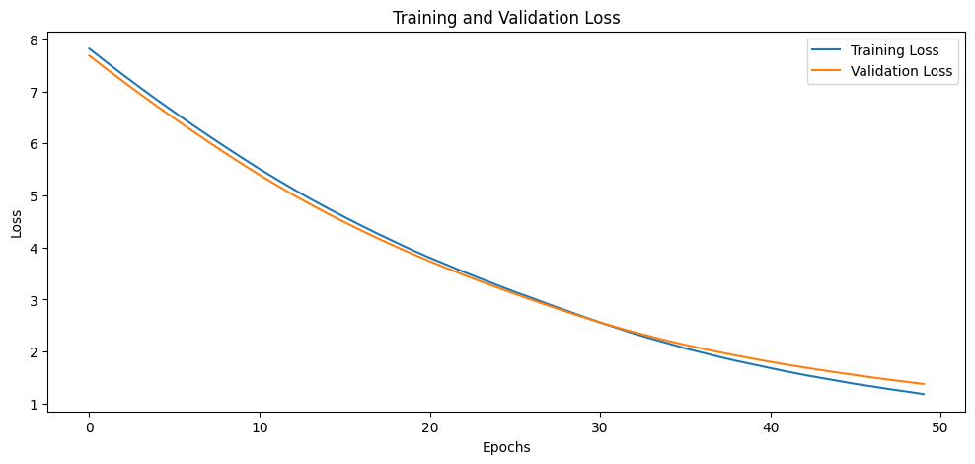Confusion Matrix of HybridNet Results
2. Training and Validation Loss Epochs
3. CLASSIFICATION REPORT:

|  |  |  |  |  |
| --- | --- | --- | --- | --- |
|  | Precision | Recall | F1-score | support |
| 0 | 0.86 | 0.86 | 0.86 | 2500 |
| 1 | 0.86 | 0.86 | 0.86 | 2500 |
| accuracy |  |  | 0.86 | 5000 |
| Mac avg | 0.86 | 0.86 | 0.86 | 5000 |
| Weighted avg | 0.86 | 0.86 | 0.86 | 5000 |

The ConvBiLSTM-AttnNet model emerged as the best performer among the three, achieving the highest accuracy, F1 Score, and AUC. Its architecture, which integrates convolutional and bidirectional LSTM layers with an attention mechanism, enables it to effectively capture both local features and long-term dependencies in the text, while the attention layer enhances focus on contextually important elements within the tweet. This combination of architectural elements explains its superior performance, especially in capturing the nuanced language associated with mental health topics on social media.ConvLSTM-AttentionNet, with a simpler architecture that excludes bidirectional LSTM, performed slightly below ConvBiLSTM-AttnNet. However, it achieved commendable accuracy and AUC scores, demonstrating that a streamlined architecture with attention mechanisms can still effectively classify mental health-related text. This model may be preferred in scenarios that prioritize computational efficiency without significantly compromising performance.HybridNet, while ranking the lowest in terms of accuracy and AUC, still provides reliable results with balanced performance metrics. Its use of L2 regularization contributes to model robustness, making it less susceptible to overfitting. HybridNet may be suitable for applications that require a simpler model with moderate performance and stability over different datasets.

All three models performed well in detecting depressive symptoms from Twitter data, with ConvBiLSTM-AttnNet showing the best overall performance. The integration of convolutional, sequential, and attention mechanisms across these models demonstrates the effectiveness of hybrid architectures in extracting meaningful patterns from social media text. The results validate our approach, highlighting the potential of deep learning models to support mental health monitoring based on real-time social media data.Each model’s performance across metrics demonstrates its suitability for different deployment scenarios, whether prioritizing high precision, balanced performance, or computational efficiency. These findings underscore the importance of model architecture in designing effective mental health classification systems and suggest promising directions for future research in applying hybrid deep learning techniques to unstructured text data.

* 1. **CONCLUSION AND FUTURE RESEARCH**

This study presented a comprehensive approach to detecting depressive indicators within Twitter data using advanced hybrid deep learning models. By combining convolutional, recurrent, and attention layers, our models effectively captured complex textual patterns associated with mental health symptoms, demonstrating that hybrid architectures can significantly improve mental health classification from social media data. The ConvBiLSTM-AttnNet model, in particular, emerged as the most robust, achieving the highest AUC and accuracy scores. These results underscore the value of leveraging both sequential dependencies and attention mechanisms in analyzing unstructured text data from social platforms. Our approach offers a scalable solution for mental health monitoring, potentially assisting clinicians and researchers in identifying at-risk individuals based on real-time social media data.

While this research has shown promising results, several areas could be explored to further advance the effectiveness of mental health classification from social media data:Future research could benefit from utilizing larger and more diverse datasets, covering a wider range of mental health conditions beyond depression. Incorporating data from multiple social media platforms, such as Reddit, Instagram, and Facebook, would enrich the dataset, offering broader insights into online mental health discourse. This expansion could help in developing models that generalize better across platforms and capture varying linguistic styles and emotive expressions.Although our study demonstrated the effectiveness of ConvBiLSTM-AttnNet and related models, future work could explore even more advanced architectures. Incorporating transformers or graph-based neural networks could enhance the model’s capacity to capture deeper context and semantic relationships within social media text. Additionally, combining models with sentiment and emotion recognition modules may improve detection accuracy by analyzing underlying emotional states more effectively.As social media language evolves rapidly, incorporating real-time adaptations for slang, abbreviations, and emerging expressions could further enhance model performance. Regularly updating N-gram libraries and employing adaptive embeddings, like domain-specific word embeddings, would make the models more resilient to changes in language patterns across social platforms.The ability to analyze mental health indicators in real-time could provide timely interventions for users showing signs of mental distress. Implementing a model capable of real-time analysis on social media streams would be invaluable for proactive mental health monitoring. Additionally, expanding this approach to handle multilingual data would enhance its applicability across different language groups and cultural contexts.Incorporating explainable AI (XAI) techniques into mental health classification models would enable greater transparency, making it easier for mental health professionals to interpret model outputs. Attention mechanisms and visual explainability tools, such as SHAP or LIME, could provide insights into the aspects of social media text that contribute most to predictions, increasing the model's utility in clinical settings.This study lays a strong foundation for mental health classification from social media data, demonstrating the potential of hybrid deep learning models. However, by advancing the dataset, model architecture, and language adaptability, future research can further enhance the capabilities and applicability of these models, ultimately contributing to more effective, scalable, and ethically responsible mental health monitoring solutions on social media platforms.

**Reference-**

1. L. Liu, "Research on Logistic Regression Algorithm of Breast Cancer Diagnose Data by Machine Learning," *2018 International Conference on Robots & Intelligent System (ICRIS)*, Changsha, China, 2018, pp. 157-160, doi: 10.1109/ICRIS.2018.00049.
2. Brandon A. Kohrt1,2, Nagendra P. Luitel1* Abstract, Prakash Acharya1 and Mark J. D. Jordans1,3,4
3. Kailai Yanga, Tianlin Zhanga, Sophia Ananiadoua,b,
4. Learning Riya Aggarwal 1Computer Science and Engineering, Amity University Noida, Uttar Pradesh, India 1riyaagg09@gmail.com Anjali Goyal2 2 School of Engineering and Technology, Sharda University Greater Noida, Uttar Pradesh, India
5. A. Deshpande and M. Kappali, "Coordination of Energy Storage Systems and Closed Loop Converter for Regulating Voltage of PV System," *2020 IEEE International Conference on Electronics, Computing and Communication Technologies (CONECCT)*, Bangalore, India, 2020, pp. 1-5, doi:10.1109/CONECCT50063.2020.9198444.
6. Genaro K, Fabris D, Arantes ALF, Zuardi AW, Crippa JAS, Prado WA. Cannabidiol Is a Potential Therapeutic for the Affective-Motivational Dimension of Incision Pain in Rats. Front Pharmacol. 2017 Jun 21;8:391. doi: 10.3389/fphar.2017.00391. PMID: 28680401; PMCID: PMC5478794.
7. Chen X, Li X, Zhang JJ, Han Y, Kan J, Chen L, Qiu C, Santoso T, Paiboon C, Kwan TW, Sheiban I, Leon MB, Stone GW, Chen SL; DKCRUSH-V Investigators. 3-Year Outcomes of the DKCRUSH-V Trial Comparing DK Crush With Provisional Stenting for Left Main Bifurcation Lesions. JACC Cardiovasc Interv. 2019 Oct 14;12(19):1927-1937. doi: 10.1016/j.jcin.2019.04.056. Epub 2019 Sep 11. PMID: 31521645.
8. †Hong Chen and Songhua Hu contributed equally to this work and should be considered co-first authors. 3School of Mathematic and Statistic, Hubei University of Science and Technology, Xianning, China Full list of author information is available at the end of the article
9. R. MurtiRawat, S. Panchal, V. K. Singh and Y. Panchal, "Breast Cancer Detection Using K-Nearest Neighbors, Logistic Regression and Ensemble Learning," *2020 International Conference on Electronics and Sustainable Communication Systems (ICESC)*, Coimbatore, India, 2020, pp. 534-540, doi: 10.1109/ICESC48915.2020.9155783.
10. T. Hossain, F. S. Shishir, M. Ashraf, M. A. Al Nasim and F. Muhammad Shah, "Brain Tumor Detection Using Convolutional Neural Network," *2019 1st International Conference on Advances in Science, Engineering and Robotics Technology (ICASERT)*, Dhaka, Bangladesh, 2019, pp. 1-6, doi: 10.1109/ICASERT.2019.8934561.
11. N. Klugman, J. Vedral and J. Lang, "Field-based Model of Flux Compression Generators," *2020 International Applied Computational Electromagnetics Society Symposium (ACES)*, Monterey, CA, USA, 2020, pp. 1-2, doi: 10.23919/ACES49320.2020.9196197.
12. Van den Berg JD, Quintens L, Zhan Y, Hoekstra H. Why address posterior tibial plateau fractures? Injury. 2020 Dec;51(12):2779-2785. doi: 10.1016/j.injury.2020.09.011. Epub 2020 Sep 16. PMID: 32958346.
13. Ting L, Yan-Hong L, Song Z, Chun-Rong X, Xuan D, Jian-Feng Z, Wei L, Qing-Jie Y, Kun Y. [Rapid detection of *Schistosoma japonicum*-infected snails with recombinase-aided isothermal amplification assay]. Zhongguo Xue Xi Chong Bing Fang Zhi Za Zhi. 2019 Apr 24;31(2):109-114. Chinese. doi: 10.16250/j.32.1374.2019026. PMID: 31184038.
14. M. R. Machado, S. Karray and I. T. de Sousa, "LightGBM: an Effective Decision Tree Gradient Boosting Method to Predict Customer Loyalty in the Finance Industry," *2019 14th International Conference on Computer Science & Education (ICCSE)*, Toronto, ON, Canada, 2019, pp. 1111-1116, doi: 10.1109/ICCSE.2019.8845529.
15. https://github.com/Microsoft/LightGBM 2http://docs.h2o.ai/h2o/latest-stable/h2o-docs/data-science/gbm.html 3https://github.com/catboost/catboost
16. KDD’18, August 19–23, 2018, London, United Kingdom ©2018 Copyright held by the owner/author(s). Publication rights licensed to Associa tion for Computing Machinery. ACMISBN978-1-4503-5552-0/18/08...$15.00
17. S. Sehgal, H. Singh, M. Agarwal, V. Bhasker and Shantanu, "Data analysis using principal component analysis," *2014 International Conference on Medical Imaging, m-Health and Emerging Communication Systems (MedCom)*, Greater Noida, India, 2014, pp. 45-48, doi: 10.1109/MedCom.2014.7005973.
18. D. Tomar, Y. Prasad, M. K. Thakur and K. K. Biswas, "Feature Selection Using Autoencoders," *2017 International Conference on Machine Learning and Data Science (MLDS)*, Noida, India, 2017, pp. 56-60, doi: 10.1109/MLDS.2017.20.
19. Rai NK, Rim KI, Wulandari EW, Subrata F, Sugihantono A, Sitohang V. Strengthening emergency preparedness and response systems: experience from Indonesia. WHO South East Asia J Public Health. 2020 Apr;9(1):26-31. doi: 10.4103/2224-3151.282992. PMID: 32341218.
20. Y. Zhang, X. Li, L. Pang, Y. He, G. Ren and J. Li, "A 2-D Geometry-Based Stochastic Channel Model for 5G Massive MIMO Communications in Real Propagation Environments," in *IEEE Systems Journal*, vol. 15, no. 1, pp. 307-318, March 2021, doi: 10.1109/JSYST.2020.2971062.
21. Y. Li, R. Wang, H. Liu, H. Jiang, S. Shan and X. Chen, "Two Birds, One Stone: Jointly Learning Binary Code for Large-Scale Face Image Retrieval and Attributes Prediction," *2015 IEEE International Conference on Computer Vision (ICCV)*, Santiago, Chile, 2015, pp. 3819-3827, doi: 10.1109/ICCV.2015.435.
22. Zhang C, Kong Y, Shen K. The Age, Sex, and Geographical Distribution of Self-Reported Asthma Triggers on Children With Asthma in China. Front Pediatr. 2021 Sep 3;9:689024. doi: 10.3389/fped.2021.689024. PMID: 34540763; PMCID: PMC8448385.
23. S. Zade, R. Korde, R. Sonone and M. Shah, "Performance Analysis of Parallel Image Processing Operations," *2020 International Conference on Communication and Signal Processing (ICCSP)*, Chennai, India, 2020, pp. 0597-0601, doi: 10.1109/ICCSP48568.2020.9182069.
24. A. -r. Mohamed, T. N. Sainath, G. Dahl, B. Ramabhadran, G. E. Hinton and M. A. Picheny, "Deep Belief Networks using discriminative features for phone recognition," *2011 IEEE International Conference on Acoustics, Speech and Signal Processing (ICASSP)*, Prague, Czech Republic, 2011, pp. 5060-5063, doi: 10.1109/ICASSP.2011.5947494.
25. Brands MT, Verbeek ALM, Geurts SME, Merkx MAW. Gepersonaliseerde nacontrole bij patiënten die curatief zijn behandeld voor een plaveiselcelcarcinoom in de mondholte [Personalised follow-ups for patients curatively treated for squamous cell carcinoma in the oral cavity]. Ned Tijdschr Tandheelkd. 2021 Mar;128(3):167-172. Dutch. doi: 10.5177/ntvt.2021.03.20112. PMID: 33734223.
26. Taylor B, Cleary S. A retrospective, observational study of medicolegal cases against obstetricians and gynaecologists in South Africa's private sector. S Afr Med J. 2021 Jun 30;111(7):661-667. doi: 10.7196/SAMJ.2021.v111i7.15511. PMID: 34382550.
27. V. K. V and P. Samuel, "A Multinomial Naïve Bayes Classifier for identifying Actors and Use Cases from Software Requirement Specification documents," *2022 2nd International Conference on Intelligent Technologies (CONIT)*, Hubli, India, 2022, pp. 1-5, doi: 10.1109/CONIT55038.2022.9848290.
28. Genaro K, Fabris D, Arantes ALF, Zuardi AW, Crippa JAS and Prado WA (2017) Cannabidiol Is a Potential Therapeutic for the Affective-Motivational Dimension of Incision Pain in Rats. Front. Pharmacol. 8:391. doi: 10.3389/fphar.2017.00391
29. A. Zafar and S. Chitnis, "Survey of Depression Detection using Social Networking Sites via Data Mining," *2020 10th International Conference on Cloud Computing, Data Science & Engineering (Confluence)*, Noida, India, 2020, pp. 88-93, doi: 10.1109/Confluence47617.2020.9058189.
30. Chen X, Li X, Zhang JJ, Han Y, Kan J, Chen L, Qiu C, Santoso T, Paiboon C, Kwan TW, Sheiban I, Leon MB, Stone GW, Chen SL; DKCRUSH-V Investigators. 3-Year Outcomes of the DKCRUSH-V Trial Comparing DK Crush With Provisional Stenting for Left Main Bifurcation Lesions. JACC Cardiovasc Interv. 2019 Oct 14;12(19):1927-1937. doi: 10.1016/j.jcin.2019.04.056. Epub 2019 Sep 11. PMID: 31521645.